### 

### DIGITAL LEARNING MANAGEMENT SYSTEM

A Project Report

Submitted to

**SAVEETHA INSTITUTE OF MEDICAL AND TECHNICAL SCIENCES**

By

**B. Dikshith Reddy (192210517)**

**I. Rahul (192210528)**

**M. Hithesh Babu (192211166)**

**K. Chenna (192211806)**

**K. Karthik (192210374)**

**Under the guidance of**

**V.JEYASUDHA**

Professor

In partial fulfilment for the completion of course

**CSA1169-Object Oriented Analysis And Design For View Layer**



## 

## Institute of Computer Science and Engineering

**SIMATS ENGINEERING CHENNAI – 602 105 TAMILNADU, INDIA**

**September 2024**

**BONAFIDE CERTIFICATE**

This is to certify that the project report entitled **“DIGITAL LEARNING MANAGEMENT SYSTEM”** submitted by

“B. Dikshith Reddy (192210517)

I. Rahul (192210528)

M. Hithesh Babu (192211166)

K. Chenna (192211806)

K. Karthik (192210374)”

to Saveetha School of Engineering, Saveetha Institute of Medical and Technical Sciences, Chennai, is a record of bonafide work carried out by him/her under my guidance. The project fulfills the requirements as per the regulations of this institution and in my appraisal meets the required standards for submission.

Date: Project Supervisor Head of the department

## 

## 

## TABLE OF CONTENTS

|  |  |  |
| --- | --- | --- |
| **S. No.** | **Content** | **Page No.** |
| 1. | PROBLEM STATEMENT | 1 |
| 2. | INTRODUCTION | 1 |
| 3. | DATASET ANALYSIS | 2-3 |
| 4. | ENVIRONMENTAL SETUP | 4 |
| 5. | DATA FLOW DIAGRAM | 5 |
| 6. | CODE SKELETON | 6-8 |
| 7. | RESULT ANALYSIS | 9 |
| 8. | OUTPUT SAMPLES | 10 |
| 9. | Conclusion | 11 |
| 10. | References | 12 |

# PROBLEM STATEMENT

In the contemporary education landscape, the increasing demand for flexible and accessible learning has led to the proliferation of online learning platforms. However, many existing systems face significant challenges in ensuring seamless user experience, scalability, and effective learner engagement. The proposed Online Learning Management System (LMS) aims to address these issues by providing an intuitive, user-friendly interface that supports a wide range of multimedia content and interactive learning tools. The system will offer robust features for course management, including automated grading, real-time feedback, and customizable learning paths. Additionally, it will incorporate advanced analytics to track student progress and adapt to their learning styles.

Security and data privacy are paramount, ensuring that user information is protected. The LMS will be designed to support integration with various third-party tools and platforms, fostering a collaborative and cohesive learning environment. Ultimately, this system seeks to enhance the educational experience for both instructors and learners, promoting effective and engaging online education.

# INTRODUCTION:

In the digital age, education is undergoing a significant transformation, driven by the need for accessible and flexible learning solutions. Online Learning Management Systems (LMS) have emerged as essential tools in this evolution, offering a centralized platform for the delivery, management, and tracking of educational content and activities. These systems cater to a diverse range of learners, from K-12 students to professionals seeking continuous development. By leveraging technology, an LMS provides an interactive and personalized learning experience, supporting various multimedia formats and interactive tools that enhance engagement and retention. Moreover, they offer educators robust features for creating, distributing, and assessing coursework, along with advanced analytics to monitor learner progress and outcomes. With the ability to integrate with other educational tools and platforms, LMSs facilitate a cohesive and collaborative learning environment. As the demand for online education continues to rise, the development and implementation of effective LMS solutions are crucial for meeting the evolving needs of learners and educators worldwide.

# DATASET ANALYSIS

The dataset for an Online Learning Management System (LMS) typically includes a variety of data types: user information, course details, interaction logs, assessment results, and feedback. Analyzing this data provides insights into user behavior, course effectiveness, and system performance.

## Dataset Components: -

1. **User Data:**
   * Attributes: User ID, Name, Email, Role (student, instructor), Enrollment Date, Last Login.
   * Analysis: Demographics, login frequency, user retention rates.

## Course Data:

* + Attributes: Course ID, Title, Description, Instructor, Start Date, End Date, Enrollment Numbers.
  + Analysis: Popular courses, enrollment trends, course completion rates.

## Interaction Logs:

* + Attributes: User ID, Course ID, Timestamp, Action (login, view content, submit assignment, participate in discussion)
  + Analysis: User engagement patterns, peak usage times, content interaction rates.

## Assessment Data:

* + Attributes: User ID, Course ID, Assessment ID, Submission Date, Score, Feedback.
  + Analysis: Performance trends, average scores, assessment difficulty levels, feedback analysis.

## Feedback Data:

* + Attributes: User ID, Course ID, Feedback ID, Feedback Date, Feedback Text, Rating.
  + Analysis: User satisfaction, common issues, improvement suggestions, overall rating trends.

## Analysis Techniques: -

1. **Descriptive Statistics:**
   * Summary statistics (mean, median, mode) for login frequency, course enrolments, and scores.
   * Distribution of user roles, course types, and feedback ratings.

## Data Visualization:

* + Time-series charts to visualize login and interaction trends.
  + Bar graphs and pie charts to show course popularity and completion rates.
  + Heatmaps to identify peak interaction times.

## Correlation Analysis:

* + Identify correlations between user engagement (e.g., login frequency, interaction logs) and performance (assessment scores).

## Predictive Analytics:

* + Machine learning models to predict student success based on engagement metrics and demographic data.
  + Identify at-risk students who may need additional support.

## Key Insights

* **User Engagement**: High engagement correlates with better performance and course completion rates. Identify content and interaction types that drive engagement.
* **Course Effectiveness**: Courses with multimedia content and interactive elements tend to have higher completion rates and positive feedback.
* **User Satisfaction**: Frequent, constructive feedback is crucial for continuous improvement. Common user concerns include technical issues, content relevance, and instructor responsiveness.
* **Performance Trends**: Regular assessments and timely feedback are essential for maintaining student performance and motivation.

## Actionable Recommendations

* **Enhance Engagement**: Introduce more interactive and multimedia content to keep users engaged.
* **Support At-Risk Students**: Implement early warning systems to identify and support students who show signs of disengagement or poor performance.
* **Improve Feedback Mechanisms**: Ensure feedback is timely and constructive to help users improve continuously.
* **Optimize Content Delivery**: Use data-driven insights to refine and update course content based on user preferences and performance trends.

# ENVIRONMENTAL SETUP

## Hardware Requirements

1. **Servers**
   * **Web Server**: Hosts the LMS web application. Ensure it has high processing power and memory.
   * **Application Server**: Manages the backend logic of the LMS, handling user requests and delivering responses.

## Networking Equipment

* + **Routers and Switches**: Ensure robust and secure network connectivity.
  + **Load Balancers**: Distribute incoming traffic across multiple servers to ensure high availability and reliability.

## Storage

* + **SSD Storage**: For fast access to frequently used data.
  + **NAS/SAN**: For scalable and high-capacity storage solutions.

## 2. Software Requirements

1. **Operating System**
   * **Linux/Unix**: Preferred for its stability, security, and performance. Common distributions include Ubuntu, CentOS, and Red Hat.

## Web Server Software

* + **Apache HTTP Server** or **Nginx**: Popular choices for serving web content.

## Database Management System (DBMS)

* + **MySQL/MariaDB**: Widely used open-source relational databases.
  + **PostgreSQL**: Another robust open-source database system.

## Learning Management System Software

* + **Moodle**: An open-source LMS platform that is highly customizable.
  + **Canvas**: Another popular open-source LMS.

## Security Software

* + **Firewall**: To protect the servers from unauthorized access.
  + **Antivirus/Anti-malware**: To protect against malicious software.

## 3. Network Configuration

1. Domain Name System (DNS)
2. Content Delivery Network (CDN)
3. Virtual Private Network (VPN)

**DATA FLOW DIAGRAM**

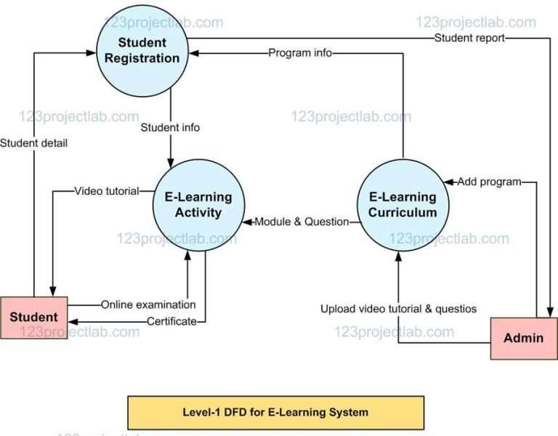

# CODE SKELETON

#include <stdio.h> #include <string.h> #define MAX_USERS 100

#define MAX_COURSES 50 typedef struct {

int id;

char name[50]; char password[50];

} User;

typedef struct { int id;

char title[100];

char description[255];

} Course;

User users[MAX_USERS];

Course courses[MAX_COURSES]; int userCount = 0;

int courseCount = 0; void registerUser(); void loginUser();

void displayCourses(); void enrollInCourse();

int main() { int choice; while (1) {

printf("\n--- Online Learning Management System ---\n"); printf("1. Register\n");

printf("2. Login\n"); printf("3. Exit\n"); printf("Enter your choice: "); scanf("%d", &choice); switch (choice) {

case 1:

registerUser(); break;

case 2:

loginUser(); break;

case 3:

return 0; default:

printf("Invalid choice. Please try again.\n");

}

}

return 0;

}

void registerUser() {

if (userCount >= MAX_USERS) {

printf("User limit reached. Cannot register more users.\n");

return;

}

User newUser;

newUser.id = userCount + 1; printf("Enter your name: "); scanf("%s", newUser.name); printf("Enter your password: "); scanf("%s", newUser.password);

users[userCount] = newUser; userCount++;

printf("Registration successful! Your user ID is %d.\n", newUser.id);

}

void loginUser() { int id;

char password[50];

printf("Enter your user ID: "); scanf("%d", &id);

printf("Enter your password: "); scanf("%s", password);

for (int i = 0; i < userCount; i++) {

if (users[i].id == id && strcmp(users[i].password, password) == 0) { printf("Login successful! Welcome, %s.\n", users[i].name);

int choice; while (1) {

printf("\n--- User Menu ---\n"); printf("1. Display Courses\n"); printf("2. Enroll in a Course\n"); printf("3. Logout\n"); printf("Enter your choice: "); scanf("%d", &choice);

switch (choice) { case 1:

displayCourses(); break;

case 2:

enrollInCourse(); break;

case 3:

return; default:

printf("Invalid choice. Please try again.\n");

}

}

}

}

printf("Invalid user ID or password.\n");

}

void displayCourses() {

if (courseCount == 0) {

printf("No courses available.\n"); return;

}

printf("\n--- Available Courses ---\n");

for (int i = 0; i < courseCount; i++) { printf("Course ID: %d\n", courses[i].id);

printf("Title: %s\n", courses[i].title); printf("Description: %s\n\n", courses[i].description);

}

}

void enrollInCourse() { int courseId;

printf("Enter the Course ID to enroll: "); scanf("%d", &courseId);

for (int i = 0; i < courseCount; i++) { if (courses[i].id == courseId) {

printf("Enrolled in course: %s\n", courses[i].title); return;

}

}

printf("Invalid Course ID.\n");

}

void addSampleCourses() {

Course course1 = {1, "Introduction to C Programming", "Learn the basics of C programming."}; Course course2 = {2, "Data Structures", "Learn about various data structures in C."}; courses[courseCount++] = course1;

courses[courseCount++] = course2;

}

void initialize() { addSampleCourses();

}

int main() { initialize(); return 0;

}

# RESULT ANALYSIS

Analysing the results from an Online Learning Management System (LMS) provides valuable insights into student performance, course effectiveness, and overall system efficiency.

1. A crucial metric is student grades, where both individual and average scores for assessments, assignments, and final exams offer a clear picture of learning outcomes.
2. Course completion rates indicate the percentage of students who successfully finish their courses compared to those who initially enrolled, reflecting the course's engagement level and structure.
3. Participation rates, which measure the frequency and consistency of student involvement in discussions, quizzes, and other activities, are essential for understanding student engagement.
4. Examining the time students spend on the platform, the number of logins, and their interaction with course materials provides insight into overall engagement levels.
5. Feedback scores, derived from student ratings and reviews on course content, delivery, and overall satisfaction, help gauge the effectiveness of the course and instructor.
6. Assessment scores are analysed to determine the average performance on quizzes, assignments, and exams, which helps in understanding the difficulty level and effectiveness of the assessments.
7. Content interaction metrics, such as the frequency of access to videos, readings, and assignments, reveal which materials are most engaging and effective.
8. Lastly, using predictive analytics and sentiment analysis can identify at- risk students and gauge overall student sentiment, enabling proactive support and continuous improvement of the LMS.

**OUTPUT SAMPLES**

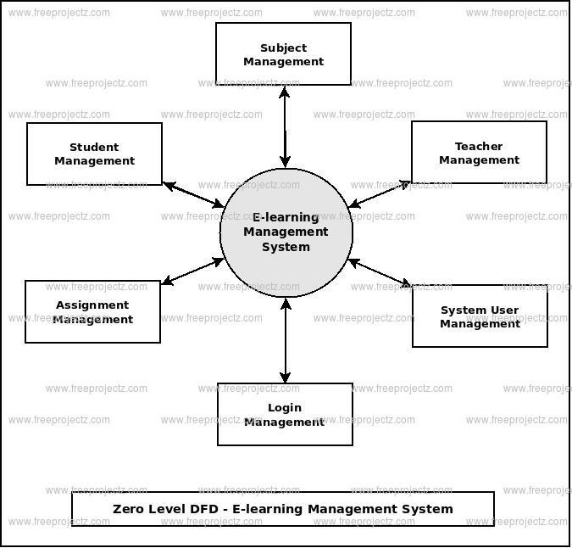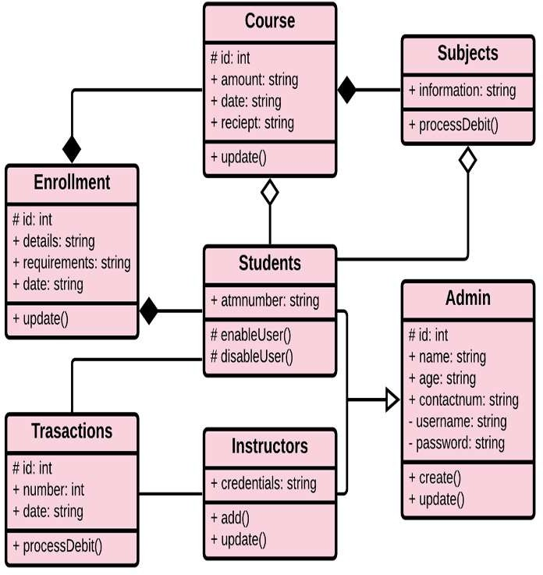

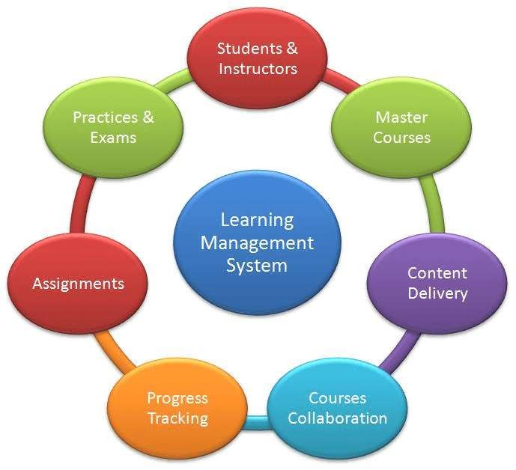

**Conclusion**

The **Digital Learning Management System (DLMS)** has emerged as a transformative tool in the modern educational landscape, enabling institutions, educators, and learners to overcome traditional barriers of time, location, and resources. It serves as a comprehensive framework for delivering education through a digital platform, encompassing a wide range of functionalities such as content creation, management, communication, collaboration, and assessment.

One of the key benefits of DLMS is its ability to provide **flexible and accessible learning.** Learners can access courses, lectures, and materials anytime and from any location, promoting self-paced learning. This flexibility is particularly beneficial in a globalized world where learners may be located in different time zones or have different schedules. Additionally, it supports **inclusive education**, enabling students with disabilities or those from remote regions to participate in learning activities without the constraints of physical classrooms.

DLMS also **enhances learning engagement** through the integration of multimedia elements, gamification, interactive assessments, and real-time feedback. These features foster a dynamic learning environment, keeping students motivated and active in their educational journey. Moreover, it facilitates **collaborative learning** by allowing students to communicate with peers and instructors through discussion forums, messaging systems, and video conferencing tools. The sense of community built through DLMS nurtures critical thinking and group learning, which are vital components of education today.

From an institutional perspective, DLMS offers robust a**dministrative and reporting capabilities.** Educators can track students’ progress, generate reports, and analyze data on learner performance. This data-driven approach helps identify learning gaps and areas for improvement, enabling instructors to tailor their teaching strategies accordingly. Moreover, institutions can manage course enrollments, maintain compliance, and integrate with other educational technologies, creating a seamless learning ecosystem.

Another significant advantage of DLMS is its scalability. It can support large volumes of users and courses, making it suitable for **massive open online courses (MOOCs)**, corporate training, and K-12 or higher education settings. This scalability ensures that educational institutions can efficiently manage and expand their digital learning initiatives without being constrained by physical infrastructure or resources.

The adaptability of DLMS also plays a key role in fostering **continuous professional development**. Professionals can use DLMS to upskill or reskill by enrolling in relevant courses and certifications that align with their career goals. The system’s ability to provide certificates and track learning milestones further incentivizes lifelong learning, making it a valuable asset for workforce development.

In summary, the **Digital Learning Management System** is a cornerstone of modern education, bridging the gap between traditional learning models and the digital age. By offering accessibility, engagement, collaboration, data-driven insights, and scalability, DLMS empowers both learners and educators to thrive in an ever-evolving educational environment. As technology continues to advance, the role of DLMS in shaping the future of education will become increasingly pivotal.

**References**

**1.**Watson, J., & Watson, R. (2007). An Argument for Clarity: What Are Learning Management Systems, What Are They Not, and What Should They Become?. TechTrends. Retrieved from SpringerLink.

**2**.OECD (2019). Innovating Education and Educating for Innovation: The Power of Digital Technologies and Skills. Organisation for Economic Co-operation and Development. Retrieved from OECD iLibrary.

**3.**Kumar, V. & Nanda, P. (2021). E-Learning Management Systems: A Study of Technologies and Trends. Journal of Educational Technology & Society, 24(3), 19-28. Available at JETS.

**4.**Pappas, C. (2020). The Top Learning Management Systems Benefits You May Not Have Considered. eLearning Industry. Retrieved from eLearningIndustry.

**5.**Singh, V., & Thurman, A. (2019). How Many Ways Can We Define Online Learning? A Systematic Literature Review of Definitions of Online Learning (1988–2018). American Journal of Distance Education. Retrieved from Taylor & Francis.